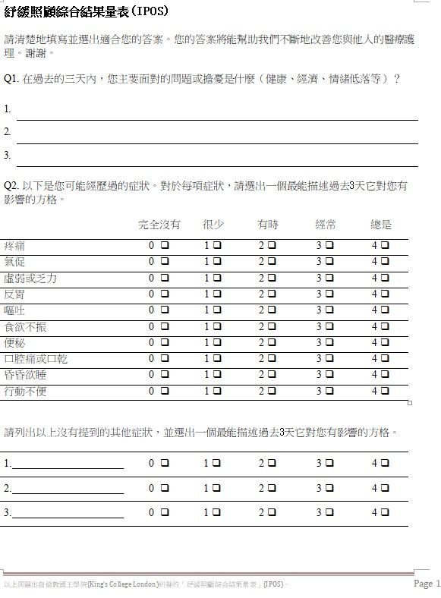

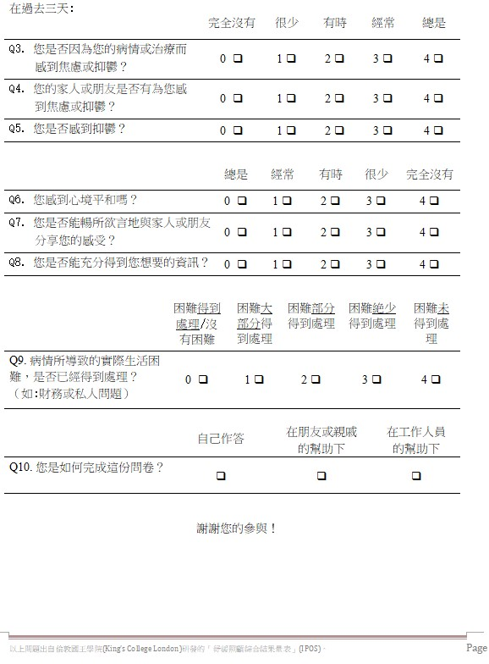

Ways for achieving functions to receive feedback for users

Apps for creating interfaces for receiving user feedback:

Figma

Two types of examples Chinese and English:

Form of questions can be made with examples of the English Version

Change starting and system page according to our own questions and main page

**Notes for Meeting:**

**Pre-prototype Creation**

Pictures With No Functions

Language: Traditional Chinese & English

Phone type: Apple & Android

Website/Mobile app interface: Mobile APP interface

Types of Questions

1.MC

2.Ranking Questions

3.Open End Questions (Maybe be cancelled for difficulty reasons)

Interfaces:

1. Login Picture
2. Choose Job/Position
3. Questionnaire Selection Page
4. Questionnaire Based Feedback Test
5. Generate Result Report

(According to the levels of the Ranking Questions)

1. No problem
2. Little problem. Give some self-suggestions to improve (Change positions)
3. Middle problem. Find doctor

3/4- Serious Problem, Solution

1. Health Carer Interface for Workers (Web page/ App Page)

Deadline: One or Two Days Before Start of Second Term 2025/01/11

Create the one combined interfaces with Cyrus for phrase II

Adding similar page like

图形用户界面, 文本, 应用程序

AI 生成的内容可能不正确。

Based on HAGO Using HKID log in

Color font size for personalization

Put together for questionnaire

Adding voice introduction/mic sign and you press to let app voice out questions and instructions. (提前录好音频文件，开发的APP的时候，点击图标或者文字播放响应的音频就ok)

Wording can be summarized for better visualization

Actions need to be made:

Create initialized User Interface

Develop the background interface, find app for gathering background information for the app

Articles:

[**https://www.proquest.com/docview/2662954069?pqorigsite=primo&sourcetype=Scholarly%20Journals**](https://www.proquest.com/docview/2662954069?pqorigsite=primo&sourcetype=Scholarly%20Journals)

[**https://support-plus.med.hku.hk/download.php**](https://support-plus.med.hku.hk/download.php)

Timeline for Project:

